**Frequency Distribution of Qualitative Data**

The **frequency distribution**of a data variable is a summary of the **data occurrence** in a collection of non-overlapping categories.

**Example**

In the data set [painters](http://www.r-tutor.com/node/19), the frequency distribution of the School variable is a summary of the number of painters in each school.

**Problem**

Find the frequency distribution of the painter schools in the data set painters.

**Solution**

We apply the table function to compute the frequency distribution of the School variable.

> library(MASS)                 # load the MASS package   
> school = painters$School      # the painter schools   
> school.freq = table(school)   # apply the table function

**Answer**

The frequency distribution of the schools is:

> school.freq   
school   
 A  B  C  D  E  F  G  H   
10  6  6 10  7  4  7  4

**Relative Frequency Distribution of Qualitative Data**

The **relative frequency distribution**of a data variable is a summary of the **frequency proportion** in a collection of non-overlapping categories.

The relationship of frequency and relative frequency is:

Relative F requency =-Frequency-
                    Sample Size


**Example**

In the data set [painters](http://www.r-tutor.com/node/19), the relative frequency distribution of the School variable is a summary of the proportion of painters in each school.

**Problem**

Find the relative frequency distribution of the painter schools in the data set painters.

**Solution**

We first apply the table function to compute the frequency distribution of the School variable.

> library(MASS)                 # load the MASS package   
> school = painters$School      # the painter schools   
> school.freq = table(school)   # apply the table function

Then we find the sample size of painters with the nrow function, and divide the frequency distribution with it. Therefore the relative frequency distribution is:

> school.relfreq = school.freq / nrow(painters)

**Answer**

The relative frequency distribution of the schools is:

> school.relfreq   
school   
       A        B        C        D        E        F   
0.185185 0.111111 0.111111 0.185185 0.129630 0.074074   
       G        H   
0.129630 0.074074

**Bar Graph**

A **bar graph**of a qualitative data sample consists of vertical parallel bars that shows the frequency distribution graphically.

**Example**

In the data set [painters](http://www.r-tutor.com/node/19), the bar graph of the School variable is a collection of vertical bars showing the number of painters in each school.

**Problem**

Find the bar graph of the painter schools in the data set painters.

**Solution**

We first apply the table function to compute the frequency distribution of the School variable.

> library(MASS)                 # load the MASS package   
> school = painters$School      # the painter schools   
> school.freq = table(school)   # apply the table function

Then we apply the barplot function to produce its bar graph.

> barplot(school.freq)         # apply the barplot function

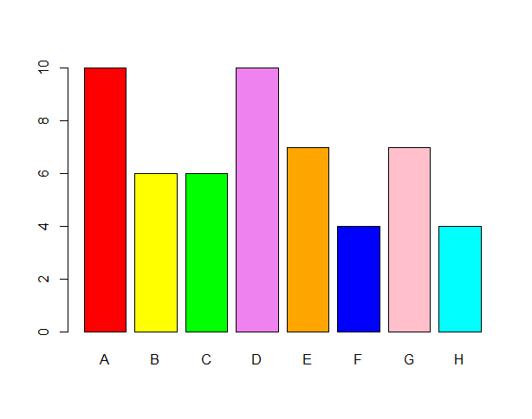

**Pie Chart**

A **pie chart**of a qualitative data sample consists of pizza wedges that shows the frequency distribution graphically.

**Example**

In the data set [painters](http://www.r-tutor.com/node/19), the pie chart of the School variable is a collection of pizza wedges showing the proportion of painters in each school.

**Problem**

Find the pie chart of the painter schools in the data set painters.

**Solution**

We first apply the table function to produce the frequency distribution of School.

> library(MASS)                 # load the MASS package   
> school = painters$School      # the painter schools   
> school.freq = table(school)   # apply the table function

Then we apply the pie function to produce its pie chart.

> pie(school.freq)              # apply the pie function

**Example Thematic Analysis**

**Research Questions:** What are students’ Perceptions of feedback?

**Doing the analysis**

Step 1: Be familiar with data

* Make notes and jot down early impressions
* Below are some early, rough notes made on the extract:
* *The students do seem to think that feedback is important but don’t always find it useful. There’s a sense that the whole assessment process, including feedback, can be seen as threatening and is not always understood. The students are very clear that they want very specific feedback that tells them how to improve in a personalized way. They want to be able to discuss their work on a one-to-one basis with lecturers, as this is more personal and also private. The emotional impact of feedback is important.*

Step 2: Generate initial codes

* Coding reduces lots of data into small chunks of meaning.
* There are different ways to code and the method will be determined by your perspective and research questions.

Step 3: Search for themes

Step 4: Review themes

Step 5: Define themes

Step 6: Write-up